Starting PASCAL Experiment

We are assuming that you have already run through the planning notebook, and the “maestronetlist_..._.json” file is ready to go.

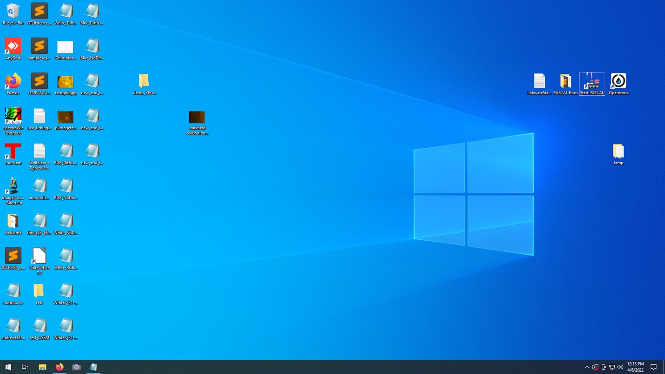

# Set up hardware

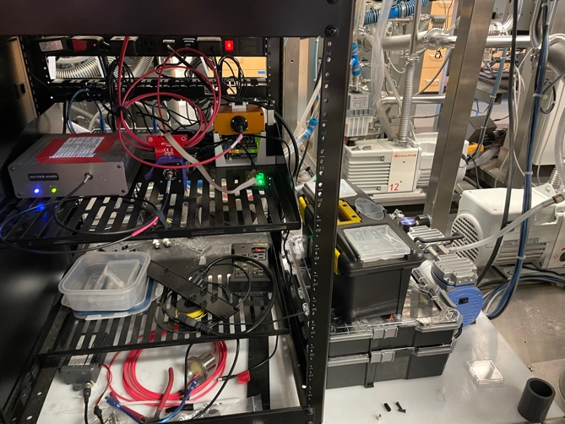

1. Turn on the transmission lamp if you are doing transmission

1. Set up Opentrons Liquid Handler

* Put liquid labware in correct positions matching the deck slots assigned in planning notebook

* Start Opentrons App
* Load protocol (OT2Protocol… .py)

* Calibrate labware positions (https://support.opentrons.com/en/articles/3499692-how- positional-calibration-works-on-the-ot-2#h_5d604f8436)
* Load and uncap all solutions that need to be mixed
* Run the Liquid Handler protocol

# Prep PASCAL

* Run shortcut on desktop to open command prompt. This step will set hotplate temperatures

>> m.load_netlist(“path/to/netlist.json”)

* Calibrate the characterization line
  + Close curtain and turn off the lights inside GB3
  + >> cl.calibrate(“path/to/netlist.json”)
    - Note- Command prompt will block until this is completed
* Load substrates into sample tray, try to center slides as much as possibleA picture containing text, indoor, cluttered

  Description automatically generated

# Execute experiment

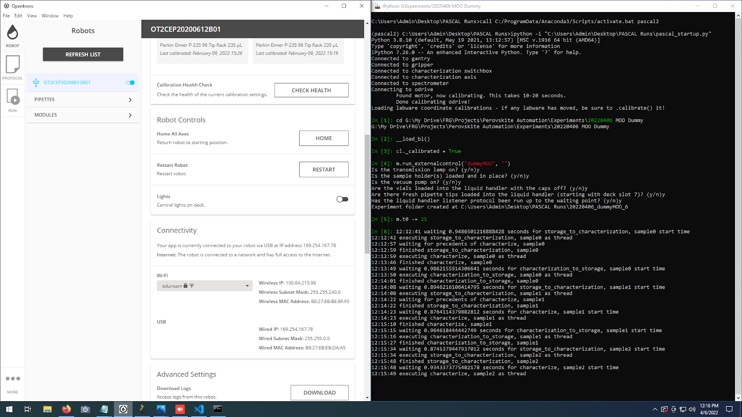

* Wait for opentrons to reach waiting point
* Look up the IP address to the liquid handler from the opentrons app

>> m.run(“ip.address.to.opentrons”)

* Follow the checklist
* Experiment started!

Useful Commands

# Moving the gantry out of the way

g.movetoclear() #moves the gantry over the characterization line, mostly out of the way to allow access to sample trays etc

# Transferring a samples from one point to another

m.transfer(source, destination)

source, destination should be coordinates to one of the hardware modules. These can be accessed as shown below:

## Single-slot hardware

cl.axis() #slot on the characterization train

sc() #spincoater chuck

## Multi-slot hardware

For hardware with more than one slot (sample trays, hotplates), you pass the slot as a string to get the coordinate for that slot. Slots are labeled like “A1”, “A2”, “C3”, etc, where the letter is the row, and the number is the column.

hp1(slot) #slot on hotplate 1 (front left)

hp2(slot) #slot on hotplate 2 (back left)

hp3(slot) #slot on hotplate 3 (back right)

st1(slot) #slot on sampletray 1 (right)

st2(slot) #slot on sampletray 2 (left)

### Examples

m.transfer(sc(), hp1(“A1”)) #move from spincoater to top left slot in hotplate 1

m.transfer(st2(“H3”), cl.axis()) #move sample onto characterization line

m.transfer(st1(“A1”), st1(“A2”)) #move sample one slot over on sample tray